TRENT UNIVERSITY SERVICE VEHICLES
DAILY CIRCLE CHECK

Week of: 14 - ___ - ___ to 14- ___ - ___ Department:

VEHICLE:_________________ Area Supervisor: __________________
LICENCE: _________________
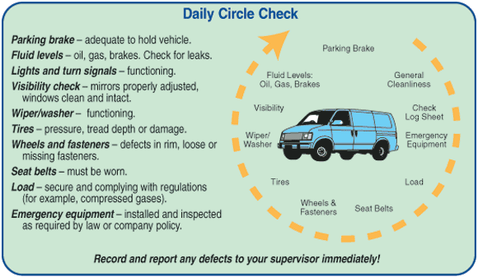
Date: | Inspector:
1) Bring your driver’s license.  2) Before starting engine, check:  - Fluid levels (oil, gas, brake, washer - evidence of leaks?)  - Visibility (damage to mirrors/windows?)  - Wipers (any damage?)  - Tires (any damage? flat?)  - Load (hitch okay? load secure?)  - Emergency equipment (present?)  3) Enter vehicle, start engine, check:  - Damage to seatbelt? Fasten belt. | - Parking brake (functioning?)  - Foot brake (functioning?)  - Clutch and gearshift (smooth?)  - Steering (any play?)  - Lights (functioning?)  - Dash control panel (operational?)  - Wipers (functioning?)  - All moving parts (any noises?)  - Horn (operational?)  - Vehicle back-up alert (operational?)  4) Proceed if no problems found.
Date: | Inspector:
1) Bring your driver’s license.  2) Before starting engine, check:  - Fluid levels (oil, gas, brake, washer - evidence of leaks?)  - Visibility (damage to mirrors/windows?)  - Wipers (any damage?)  - Tires (any damage? flat?)  - Load (hitch okay? load secure?)  - Emergency equipment (present?)  3) Enter vehicle, start engine, check:  - Damage to seatbelt? Fasten belt. | - Parking brake (functioning?)  - Foot brake (functioning?)  - Clutch and gearshift (smooth?)  - Steering (any play?)  - Lights (functioning?)  - Dash control panel (operational?)  - Wipers (functioning?)  - All moving parts (any noises?)  - Horn (operational?)  - Vehicle back-up alert (operational?)  4) Proceed if no problems found.
Date: | Inspector:
1) Bring your driver’s license.  2) Before starting engine, check:  - Fluid levels (oil, gas, brake, washer - evidence of leaks?)  - Visibility (damage to mirrors/windows?)  - Wipers (any damage?)  - Tires (any damage? flat?)  - Load (hitch okay? load secure?)  - Emergency equipment (present?)  3) Enter vehicle, start engine, check:  - Damage to seatbelt? Fasten belt. | - Parking brake (functioning?)  - Foot brake (functioning?)  - Clutch and gearshift (smooth?)  - Steering (any play?)  - Lights (functioning?)  - Dash control panel (operational?)  - Wipers (functioning?)  - All moving parts (any noises?)  - Horn (operational?)  - Vehicle back-up alert (operational?)  4) Proceed if no problems found.
Date: | Inspector:
1) Bring your driver’s license.  2) Before starting engine, check:  - Fluid levels (oil, gas, brake, washer - evidence of leaks?)  - Visibility (damage to mirrors/windows?)  - Wipers (any damage?)  - Tires (any damage? flat?)  - Load (hitch okay? load secure?)  - Emergency equipment (present?)  3) Enter vehicle, start engine, check:  - Damage to seatbelt? Fasten belt. | - Parking brake (functioning?)  - Foot brake (functioning?)  - Clutch and gearshift (smooth?)  - Steering (any play?)  - Lights (functioning?)  - Dash control panel (operational?)  - Wipers (functioning?)  - All moving parts (any noises?)  - Horn (operational?)  - Vehicle back-up alert (operational?)  4) Proceed if no problems found.
Date: | Inspector:
1) Bring your driver’s license.  2) Before starting engine, check:  - Fluid levels (oil, gas, brake, washer - evidence of leaks?)  - Visibility (damage to mirrors/windows?)  - Wipers (any damage?)  - Tires (any damage? flat?)  - Load (hitch okay? load secure?)  - Emergency equipment (present?)  3) Enter vehicle, start engine, check:  - Damage to seatbelt? Fasten belt. | - Parking brake (functioning?)  - Foot brake (functioning?)  - Clutch and gearshift (smooth?)  - Steering (any play?)  - Lights (functioning?)  - Dash control panel (operational?)  - Wipers (functioning?)  - All moving parts (any noises?)  - Horn (operational?)  - Vehicle back-up alert (operational?)  4) Proceed if no problems found.

IF YOU DISCOVER ANY PROBLEMS, REPORT TO: ____________________________
IMMEDIATELY AND DO NOT USE THE VEHICLE!

